65th ECCE GENERAL MEETING
2 – 3 June 2017, Antalya, Turkey
Crystal Tat Beach Golf Resort & Spa
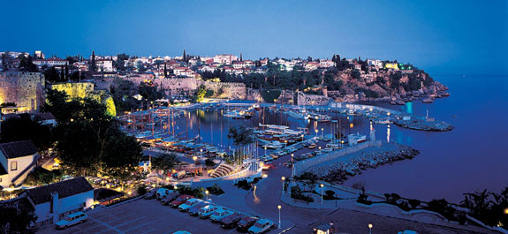

REGISTRATION FORM
Complete this form and return no later than May 15, 2017 to:
TCCE Organization Secretary (Ceylan Ozkul): tel.: +90 (312) 294 3023 E-mail: cozkul@imo.org.tr
ECCE Secretary General (Maria Karanasiou): tel..: +30 6973379151 E-mail: ecce_sps@otenet.gr
PARTICIPANT’S DETAILS
Family Name: . First Name:
Organization: Address: City, Country:
Phone: Fax: E-mail:
FLIGHTS (OPTIONAL)
Arrival:(DD/MM/YYYY)………………… No. of Flight Departure: (DD/MM/YYYY).......................... No. of Flight

1. FREE REGISTRATION

ExBo Member 1st National Delegate Invited Association 1st National Delegate

2. PAID REGISTRATION
2nd Delegate (120 EUR) name:………………………………………………………………………..
3rd Delegate (120 EUR) name:………………………………………………………………………..
4th Delegate (120 EUR) name:………………………………………………………………………..
5th Delegate (120 EUR) name:………………………………………………………………………..
Invited Association:
2nd Delegate (120 EUR) name:………………………………………………………………………..
3rd Delegate (120 EUR) name:………………………………………………………………………..
4th Delegate (120 EUR) name:………………………………………………………………………..
5th Delegate (120 EUR) name:………………………………………………………………………..
Accompanying person 1 (120 EUR) name:………………………………………………………………….
Accompanying person 2 (120 EUR) name:………………………………………………………………….
TOTAL…………………..EUROS
REGISTRATION INCLUDES: ECCE sessions, meals, coffee breaks and tour on Saturday afternoon
TOUR FOR ACCOMPANYING PERSONS (FRIDAY afternoon): City tour (Sightseeing in Antalya, a 1-hour visit to the Antalya Museum, walking tour and tea break in the Old Town) (1pm – 6pm) and tour on Saturday afternoon
METHOD OF PAYMENT:
Registration fees can be deposited to the TCCE Euro account given below or can be paid on arrival in cash (no credit cards) to TCCE Organisation Secretary Ms. Ceylan Ozkul.
TCCE euro account at Garanti Bankasi Necatibey Branch:
SWIFT Code: TGBATRISXXX
IBAN: TR87 0006 2000 1300 0009 0880 84
Beneficiary: TMMOB İNŞAAT MÜHENDİSLERİ ODASI

PLEASE SEND COPY OF BANK TRANSFER WITH THIS REGISTRATION FORM IF YOU CHOOSE THE INTERNATIONAL TRANSFER OPTION

